NAME:Rishik JK
REG.NO :192511052

CSA1702-ARTIFICIAL INTELLIGENCE
LAB EXPERIMENT

Experiment 5 – Missionaries and Cannibals

AIM
To write a Python program to solve the Missionaries and Cannibals problem safely.

ALGORITHM
- Start with 3 missionaries and 3 cannibals on the left side.
- The boat can carry a maximum of 2 persons.
- Move missionaries and cannibals from one side to another.
- Make sure cannibals never outnumber missionaries on either side when missionaries are present.
- Continue until all 3 missionaries and 3 cannibals reach the right side.
- Display the solution path.
- Stop.

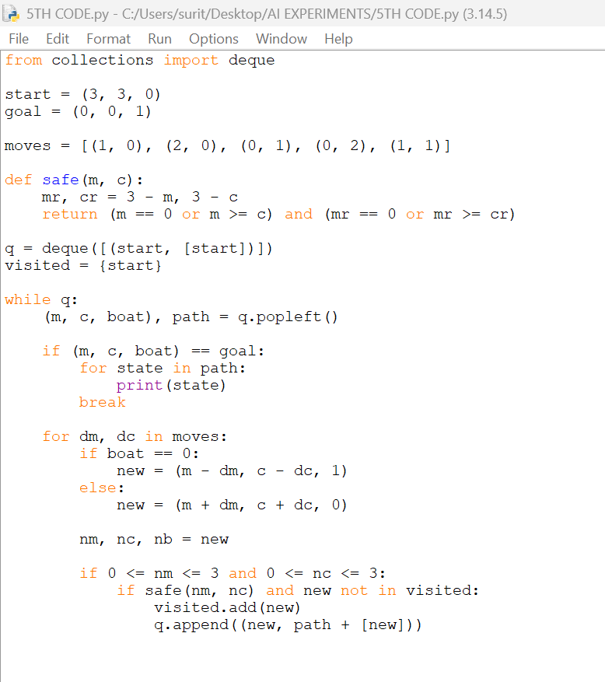

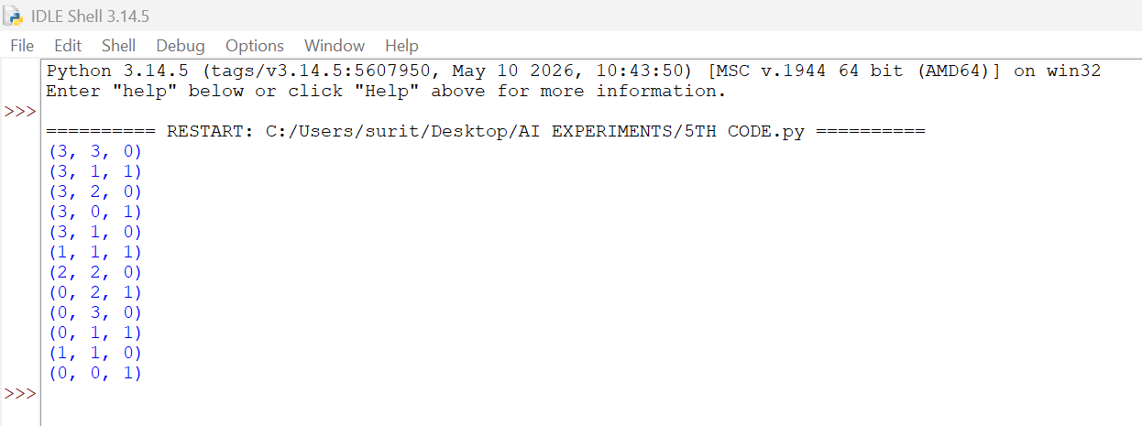

RESULT
Thus, the Missionaries and Cannibals problem was solved successfully using Python without violating the safety condition.

